Will start with the Summary tab. Break into tributary by state shapefiles.

Eventually will go more into the orange, source tabs. Its complicated through… (see notes below).

Can reach out to Jim if need help.

Studies in late 60s, understand the needs of the basin. Legislation from congress on collecting data. Upper and lower basin.

Water rights modified main eccritidel.

BOR consumptive use. Natural flow

Consumptive Use and Loss data.

Their basins were developed in the 1970s, where HUC was the 1980s, not a perfect fit. HUC delineate to a gauge, theirs delineate to a conflux. He can help us cookie cutter those if we want too.

Tributary

2019 and 2020 are place holders for now (I’d leave them out of WaDE for now to help avoid confusion).

Their data is modeled (Modified Es secn critical?)

Their consumptive use account for 1) precip and 2) accidental loss.

CP = Control Point (gauge points). Tied to a station. Sometimes they don’t match HUC exactly. Table that shows what HUCs are above that station. Also does plit at CSSR nodes (like state lines).

Orange tabs = source data over time. Change in color shows that the data was collected in a different way. Non-orange cell data is hardcoded / formulas, orange cells are source

Marco in sheet. Open results with txt.

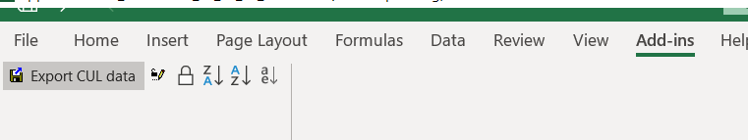

He uses his own reportingunit based on those 1970 gauges (a gauge node structure), he recommends we could do it by HUC8 though.

Have to follow the source data / formulas. Beware of what data is determined by county and what was determined by HUC (not always clear). (e.g., livestock is county and he mismatched it into HUC8). Look for a source info tab at end / scroll to bottom and see what there is. There is a document that shows a flowchart map of each ben use and how they map it.

We need a disclaimer in our data for people to, if interested, check csv source data and reach out to Jim.

Might be worth writing out a plan for Jim to see on how exactly we want to take that data and map it into wade.

HUC: minerals

County: